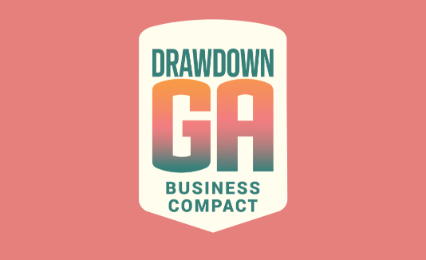
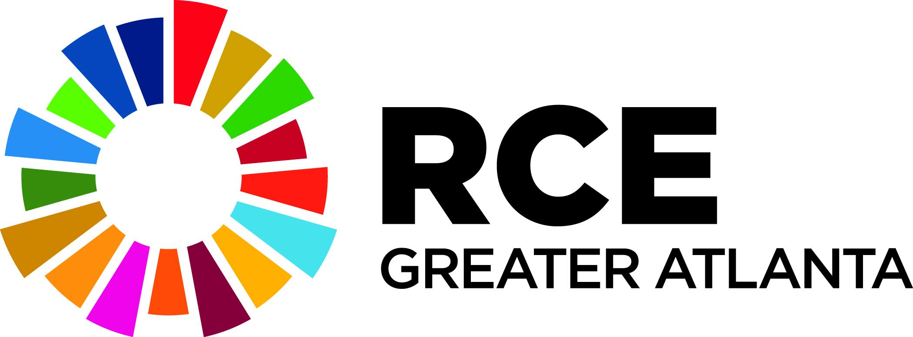

RCE/DDG Partnership Overview for Community-Based Organizations

This overview will be used to help CBOs new to the RCE Greater Atlanta find the best ways to engage with the network and its membership; the co-leads of the RCE Community of Practice for Community-Academic Partnerships will review this document and invite its author/s to join the CoP as a kind of “gateway” to RCE Greater Atlanta engagement. It will also be shared with the Drawdown Georgia Business Compact (industry/companies) to reach out to potential businesses that might be interested in supporting community-based organizations (CBOs) that are advancing the UN Sustainable Development Goals (SDGs) that align with Drawdown Georgia solutions. Finally, Georgia Tech’s Center for Sustainable Communities Research and Education (SCoRE) will use it to explore other ways for Georgia Tech to support your work. It should be completed by the CBO seeking partnerships and support. Please note that it is intended to be short and sweet - 3-4 pages at most, plus the SDG/DDG alignment table at the end. This will be used as an initial tool, to spark interest in conversation about potential partnerships. Take the prompts/questions in brackets in each section as simply suggestions re: what to include. Nothing is required - you do not even have to put something in each section or question - with the exception of the final section on alignment with the SDGs and the DDG solutions - we need to know that alignment to help identify potential interest.

Once you complete this document, send it to Anna Tinoco-Santiago at atinocosantiago1@gatech.edu, and she will follow up with you directly. If you have questions before you fill it out or while you are working on it, please feel free to get in touch. If you would like help filling it out, we may have an RCE Student Coordinator who can help you, so please let us know.

Thank you!

—----------------------------------------------------------------------------------------------------------------------------

Part 1: Organizational Overview
Email Address for Organization’s Primary Contact (likely the person filling this out!):

About the Organization:
[Name, vision and mission, goals, primary programs/activities, geographic scope, team overview/profiles (staff, board, volunteers), and year founded. What do you consider most special about your organization and the work you do?]
Role in the Community:
[Define and describe the community where you do your work. Include description of key assets and challenges, and potentially some relevant data or statistics. Describe the relationship between the organization, the staff, and the community. Would you say your work is community-based (working in/with local residents, but organizational leaders are largely new to the community or do not reside there) or community-led (organizational leaders are largely from legacy residents/families)? How/do community members participate in organizational decision-making and program planning and implementation?]
Evaluation & Reporting:
[What forms of evaluation or reporting already exist in the organization on the progress and results of its programs (if any)? How/do you collect and use data to inform planning and decision-making and demonstrate impact? Is your data qualitative, or quantitative, or a mix? Which programs are you most proud of? How do you know they’re working well? Highlight an anecdote or story of what success looks like in your work, if you’d like. Include links to any existing annual or impact reports (if you have them).]

Financial Model:
[How does your organization support its staff and programming? How do you ensure long-term financial sustainability? Share any/as much financial information as you’d like to share. If you have received grants or philanthropic support please list those here. You do not need to include exact amounts.]

Additional Information: (optional)
[Share anything else that you would like to share here to help potential partners understand what you do. For example, if you have a theory of change or logic model, you could share that here. Or feel free to share additional accomplishments, stories, etc. You are also welcome to leave this section blank.]

Part 2: Partnerships & Support
This prospectus will be used to nurture partnerships and support from the RCE Greater Atlanta and Drawdown Georgia Business Compact communities, which include members from multiple sectors, including higher education, K-12, business, nonprofit, community, and government.

General Partnerships & Support:
[What kinds of partnerships and support are you looking for in general? Include financial and non-financial (land, space, equipment, devices, student support, research, evaluation, interns, training, etc.). Are there specific types of partners you are eager to engage with around specific areas or capacities (e.g., business, college students, government, etc.)?]

Current & Upcoming Project Partnerships & Support:
[Share short descriptions of 2-3 current or upcoming projects that would benefit from partnerships and support. What SDGs do they advance? Please provide expected start and end dates or project duration, key milestones, and what kinds of partnerships/support you are looking for.]

Which of the above projects do you think the SDG Futures Fellows might be able to support in Spring Semester 2024? Note that these are groups of three students, from different universities and colleges around the Atlanta region, who work together outside of classes - for no credit or pay - to support a partner project that advances the SDGs. They are expected to spend approximately 3-4 hours per week on the project. If you are located in the Atlanta region, we would like the project to include at least a few in-person engagements if possible.]

Alignment with the UN SDGs and Drawdown Georgia Goals
Understanding at a high level how your work aligns with the SDGs and DDG will be helpful as we try to identify partners with similar interests. Please complete the alignment worksheet below.

The SDGs address various social, economic, and environmental challenges and aim to promote sustainable development, eradicate poverty, reduce inequalities, and ensure a more inclusive and equitable world for all. The Drawdown Georgia initiative advances progress toward the achievement of the SDGs by working to reach net-zero greenhouse gas emissions in the state. The 20 high-impact solutions identified by Drawdown Georgia that will advance significant emissions reduction are in the chart below along with the “beyond carbon” solutions that impact Georgia’s economy, social inequities, public health, and the environment.

UN SDG Goals | Drawdown Georgia solutions related to particular SDG targets | Organizational Alignment (check all boxes that align - or you think may align - with your core work) | Organization’s measurement of local progress on the goal (optional)
Goal 1. End poverty in all its forms everywhere
Goal 2. End hunger, achieve food security and improved nutrition and promote sustainable agriculture | Climate smart agriculture  Beyond carbon
Goal 3. Ensure healthy lives and promote well-being for all at all ages | Beyond carbon
Goal 4. Ensure inclusive and equitable quality education and promote lifelong learning opportunities for all | Beyond carbon
Goal 5. Achieve gender equality and empower all women and girls | Beyond carbon
Goal 6. Ensure availability and sustainable management of water and sanitation for all | Beyond carbon
Goal 7. Ensure access to affordable, reliable, sustainable and modern energy for all | Rooftop solar  Cogeneration  Large-scale solar  Landfill methane  Demand response  Retrofitting  Beyond carbon
Goal 8. Promote sustained, inclusive and sustainable economic growth, full and productive employment and decent work for all | Beyond carbon
Goal 9. Build resilient infrastructure, promote inclusive and sustainable industrialization and foster innovation | Beyond carbon
Goal 10. Reduce inequality within and among countries | Beyond carbon
Goal 11. Make cities and human settlements inclusive, safe, resilient and sustainable | Alternative transportation  Energy efficient cars  Energy efficient trucks  Electric vehicles  Mass transit  Beyond Carbon
Goal 12. Ensure sustainable consumption and production patterns | Reduce food waste  Recycling/Waste management  Composting  Refrigerant management  Beyond carbon
Goal 13. Take urgent action to combat climate change and its impacts | Plant-based diet  Beyond carbon
Goal 14. Conserve and sustainably use the oceans, seas and marine resources for sustainable development | Beyond carbon
Goal 15. Protect, restore and promote sustainable use of terrestrial ecosystems, sustainably manage forests, combat desertification, and halt and reverse land degradation and halt biodiversity loss | Planting trees  Wetlands protection  Forest management
Goal 16. Promote peaceful and inclusive societies for sustainable development, provide access to justice for all and build effective, accountable and inclusive institutions at all levels
Goal 17. Strengthen the means of implementation and revitalize the Global Partnership for Sustainable Development

